Practical No.5

Aim: Ethereum Transactions using Geth Console on a Private Ethereum Network

Step 1: Start Eth
Step 2: Check Validator Account Balance
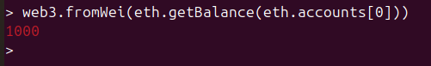

Step 3: Check Initial Nounce
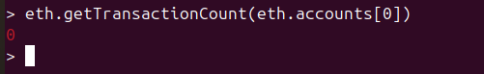

Step 4: Check Current Block Number
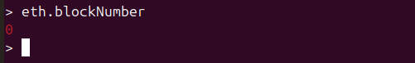

Step 5: Configure Validator
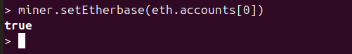

Step 6: Create Transaction of 10 Eth

Step 7: Store Transaction Hash in a Variable

Step 8: Get Transaction Block Data
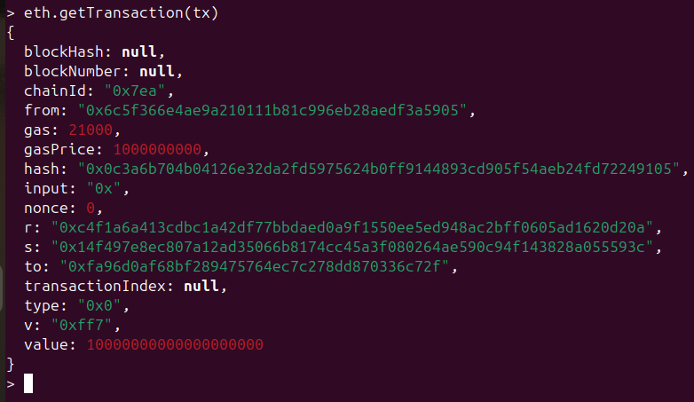

Step 9: Check Transaction Receipt
Since Miner has not start receipt cannot be generated

Step 10: Start Miner
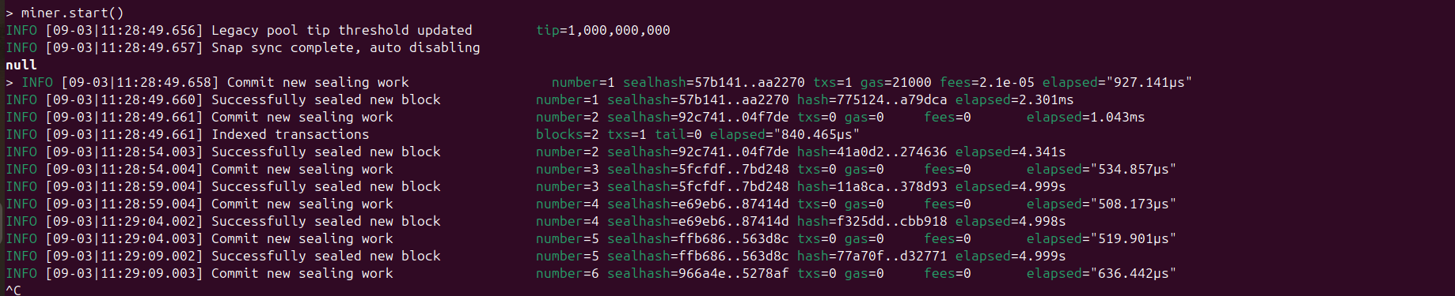

Step 11: Check Transaction Receipt Again
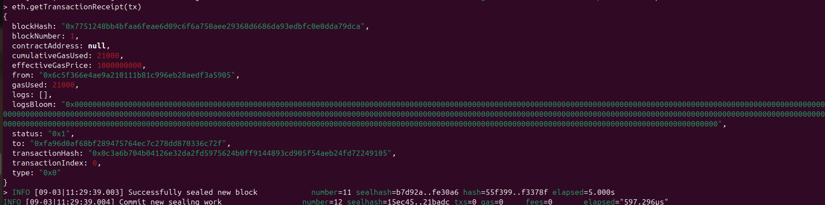

Step 12: Check Block Number Increase
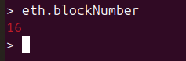

Step 13: Check Account Nounce
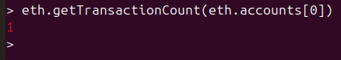

Step 14: Check Account Balance

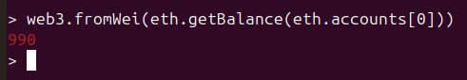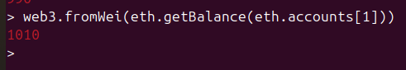

Step 15: View Latest Block
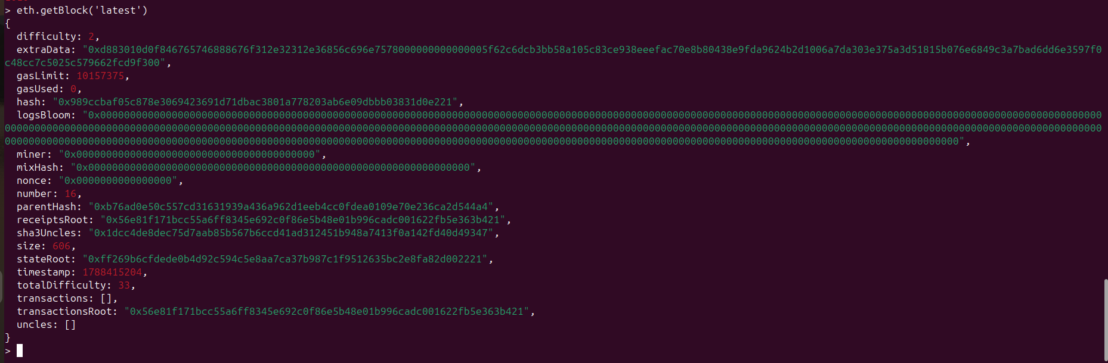

Step 16: ViewBlock Transactions

Step 17: Stop Miner

Miner.stop

